|  |  |  |  |
| --- | --- | --- | --- |
| **Actual Risk** | At Risk | # Pts at risk correctly categorized  **511** | # Pts at risk categorized as not at risk  **0** |
| No Risk | # Pts not at risk categorized as at risk  **0** | # Pts not at risk correctly categorized  **2878** |
|  |  | At Risk | No Risk |
|  |  | **Predicted Risk** | |

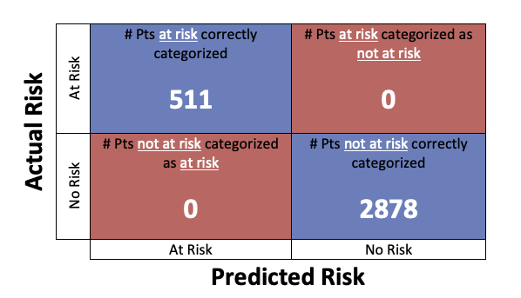

|  |  |  |  |
| --- | --- | --- | --- |
| **Actual Risk** | At Risk | # Pts at risk correctly categorized | # Pts at risk categorized as not at risk |
| No Risk | # Pts not at risk categorized as at risk | # Pts not at risk correctly categorized |
|  |  | At Risk | No Risk |
|  |  | **Predicted Risk** | |

